**11. REACTJS-HQL**

**FOLDER STRUCTURE**

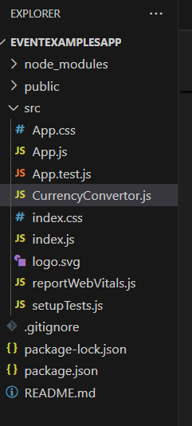

**App.js**

import React, { Component } from 'react';

import CurrencyConvertor from './CurrencyConvertor';

class App extends Component {

  constructor() {

    super();

    this.state = {

      count: 0

    };

  }

  handleIncrement = () => {

    this.setState({ count: this.state.count + 1 });

    this.sayHello();

  };

  sayHello = () => {

    console.log("Hello! This is a static message.");

  };

  handleDecrement = () => {

    this.setState({ count: this.state.count - 1 });

  };

  sayWelcome = (msg) => {

    alert(msg);

  };

  handleClick = (e) => {

    e.preventDefault(); // synthetic event

    alert("I was clicked");

  };

  render() {

    return (

      <div style={{ padding: '20px', fontFamily: 'Arial' }}>

        <h2>React Event Handling Lab</h2>

        <p>Counter: {this.state.count}</p>

        <button onClick={this.handleIncrement}>Increment</button>{' '}

        <button onClick={this.handleDecrement}>Decrement</button>

<br /><br />

        <button onClick={() => this.sayWelcome("Welcome to React Events!")}>

          Say Welcome

        </button>

<br /><br />

  <button onClick={this.handleClick}>Synthetic Event OnPress</button>

  <br /><br />

  <CurrencyConvertor />

      </div>

    );

  }

}

export default App;

**CurrencyConvertor.js**

import React, { Component } from 'react';

class CurrencyConvertor extends Component {

  constructor() {

    super();

    this.state = {

      rupees: '',

      euro: ''

    };

  }

  handleChange = (e) => {

    this.setState({ rupees: e.target.value });

  };

  handleSubmit = () => {

    const euro = (parseFloat(this.state.rupees) / 90).toFixed(2);

    this.setState({ euro });

  };

  render() {

    return (

      <div>

        <h3>Currency Convertor (INR ➡️ EUR)</h3>

        <input

          type="number"

          placeholder="Enter amount in Rupees"

          value={this.state.rupees}

          onChange={this.handleChange}

        />

        <button onClick={this.handleSubmit}>Convert</button>

  {this.state.euro && (

          <p>Converted Amount in Euro: €{this.state.euro}</p>

        )}

      </div>

    );

  }

}

export default CurrencyConvertor;

**OUTPUT**

